# PRACTICUM Programming Algorithm



**By:**

Richie Corneliu / 24091397055

Yudha Rizky Ananda / 24091397164

**INFORMATICS MANAGEMENT STUDY PROGRAM**

**FACULTY OF VOCATIONAL**

**SURABAYA STATE UNIVERSITY**

**2024**

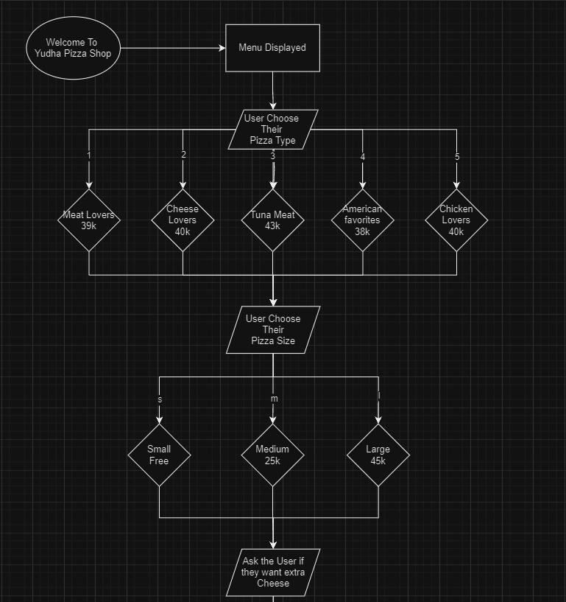

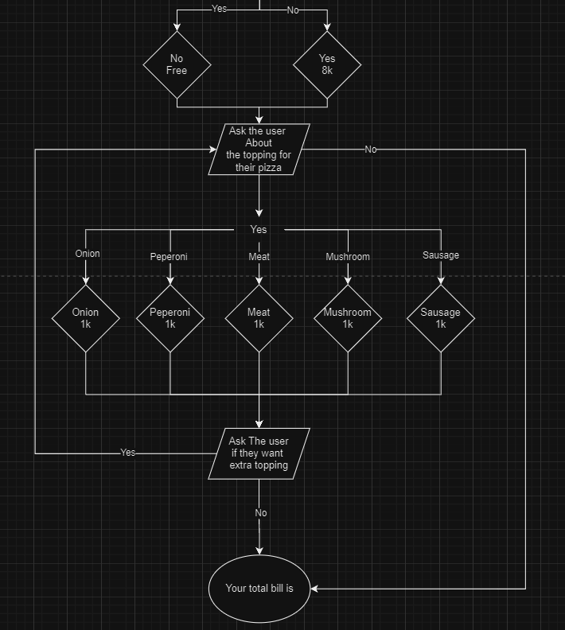

**Explanantion Flowchart :**

1. Start is to start the program
2. The Menu will be displayed
3. The user will choose their pizza type with input the number according the menu number (1-5)
4. Then the user will be asked about the size of their pizza ( S, M, L)
5. After choosing the size, user will be asked if they want the extra cheese
6. Then the user will be asked if they want topping in their pizza
7. If the user want add topping the program will show what the list of the topping and the user will input the topping. If the user don’t want add topping the program will show the bill (end)
8. After choosing the first topping, the user will be asked again if they wanted extra topping in their pizza.
9. If user wanted the extra topping, the program will show the topping. If the user don’t want the extra topping, the program will show the bill (end)
10. The last part of the program is the user total bill

**EXPLANATION SNIPPET CODE :**

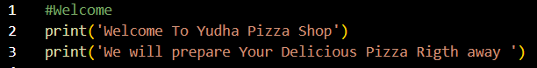<= This Code is to welcome the user

Print in line 2 is to print out “Welcome To Yudha Pizza Shop“ by using print function

Print in line 3 is to print out “We will prepare your delicious pizza right away “ by using print function. Result :



<= The very first bill

Total_harga is going to be a variable to count the bill

<= This is going ti display the menu to the user and the user will be asked the pizza type they want by input the number of the menu (1-5)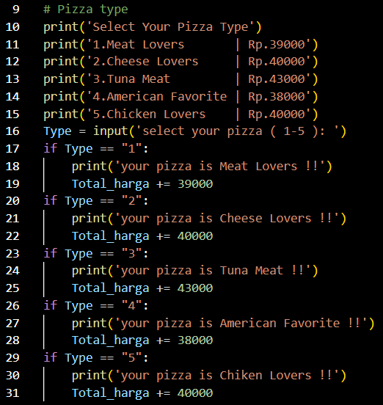

Print Function in line 10 will print out “Select your pizza type”

Print function in line 10-15 will print out the menu

If the user has input a number the input will set Type according the user input

Every if function is the responds for Type

if Type == 1, Total_harga will added Rp.39.000, set the Type as Meat lovers also print out “Your pizza is Meat Lovers !!”

if Type == 2, Total_harga will added Rp.40.000, set the Type as Cheese lovers also print out “Your pizza is Cheese Lovers !!”

if Type == 3, Total_harga will added Rp.43.000, set the Type as Tuna Meat also print out “Your pizza is Tuna Meat !!”

if Type == 4, Total_harga will added Rp.38.000, set the Type as American Favorite

also print out “Your pizza is American favorite !!”

if Type == 5, Total_harga will added Rp.40.000, set the Type as Chiken lovers also print out “Your pizza is Chicken Lovers !!”

Result:

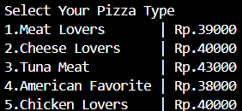

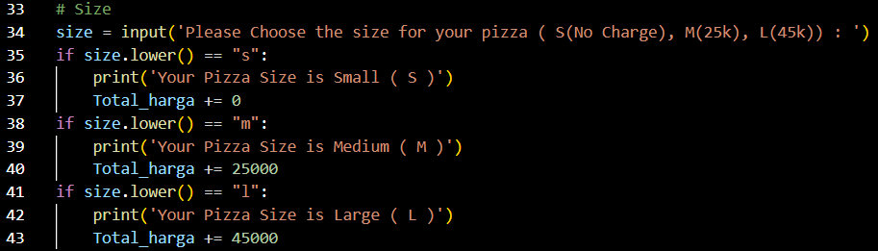

<= This will show and ask the user about their pizza size (S, M, L)

In line 34 will print out “please choose the size for your pizza (S (No charge), M(25k), L(45K))

And set the user input to Size

If size == “s”, Total_harga will be added 0

If size == “m”, Total_harga will be added 25.000

If size == “l”, Total_harga will be added 45.000

Result:



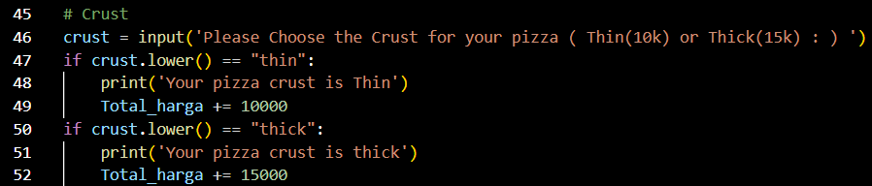

<= This code is going to display and ask the user about the crust type they want

In line 46 will print out “ Please Choose the crust for your pizza(thin(10k) or Thick(15k))

And the user input will set as crust

If crust == “thin”, Total_harga will be added 10.000, also print out “your pizza crust is thin”

If crust == “thick”, Total_harga will be added 15.000, also print out “your pizza crust is thick”

Result :



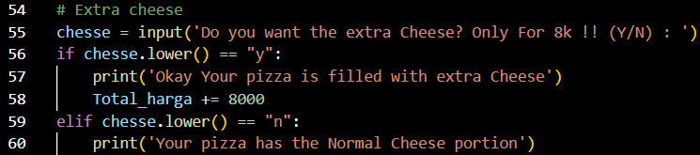<= this code will ask the user if they want extra cheese in their pizza (Y/N)

The user input will be set as cheese

If cheese == “y”, total_harga will be added 8.000 also print out “Okay your pizza is filled with extra cheese”

If cheese == “n”, total_harga will be added 8.000 also print out “your pizza has the normal cheese portion”

Result :



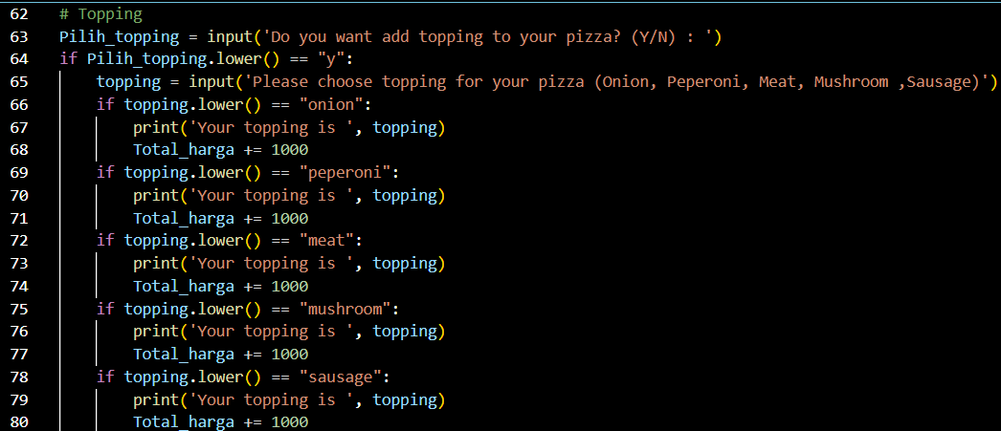<= this will ask the user if they want to add topping to their pizza (Y)

If the user input “y” then it will be set as pilih_topping

If pilih_topping == “y”, it will print out “ Please choose the topping for your pizza (onion, peperoni, meat, mushroom, sausage) and set is as topping

Then the user will input the topping they want, it will be set as topping

If topping == “onion”, total harga will be added 1.000 also it will print out “your topping is onion(topping)”

If topping == “peperoni”, total harga will be added 1.000 also it will print out “your topping is peperoni(topping)”

If topping == “meat”, total harga will be added 1.000 also it will print out “your topping is meat(topping)”

If topping == “mushroom”, total harga will be added 1.000 also it will print out “your topping is mushroom(topping)”

If topping == “sausage”, total harga will be added 1.000 also it will print out “your topping is sausage(topping)”

Result :

<= this the code to respond the user if they don’t want to add topping(N)

If the user input “n” for pilih_topping the program will print out (your pizza has no topping” and continue the program

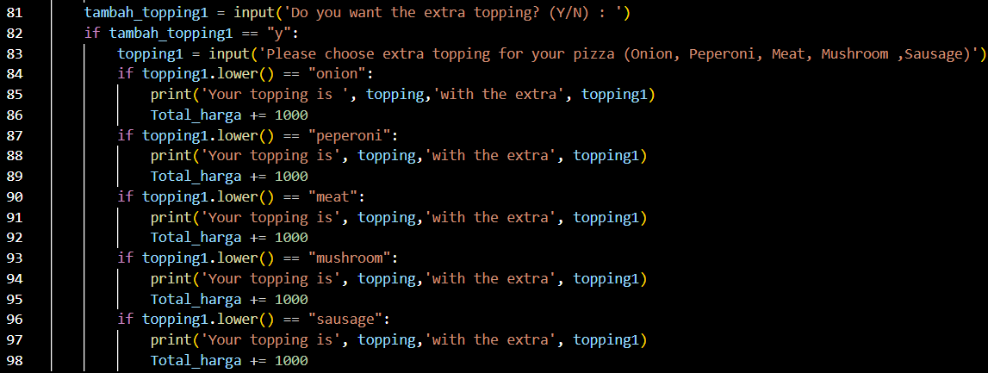<=After user choosing the first topping, this code will ask the user if they want add extra topping

If the user input “y” then it will be set as tambah_topping

If tambah_topping == “y”, it will print out “ Please choose the topping for your pizza (onion, peperoni, meat, mushroom, sausage) and set it as topping1

Then the user will input the topping they want, it will be set as topping

If topping1 == “onion”, total harga will be added 1.000 also it will print out “your topping is (topping),'with the extra', (topping1)”

If topping1 == “peperoni”, total harga will be added 1.000 also it will print out “your topping is (topping),'with the extra', (topping1)”

If topping1 == “meat”, total harga will be added 1.000 also it will print out “your topping is (topping),'with the extra', (topping1)”

If topping1 == “mushroom”, total harga will be added 1.000 also it will print out “your topping is (topping),'with the extra', (topping1)”

If topping1 == “sausage”, total harga will be added 1.000 also it will print “your topping is (topping),'with the extra', (topping1)”

Result :

If the user input “N” for tambah_topping the program will continue

<= this is the code for the total bill of the user

The code will print out “so your total bill is (total_harga))